- Open world (Minecraft generating)
- 3rd/fps (Full Character model)
- Dynamic Eco Systems (pollution, lives of creatures)

Player Mechanics:
- Movement
- Mounting (creatures)

- Item Pickup
- Inventory
- Mining
- Hunting
- Farming
- Building
- Cooking

- INCLUDES SURVIVAL MECHANICS*

Creature Mechanics:
- Movement
- Mounting (creatures)
- Reproducing
- Giving Birth

- INCLUDES SURVIVAL MECHANICS*

Environment Mechanics:
- Receiving Pollution
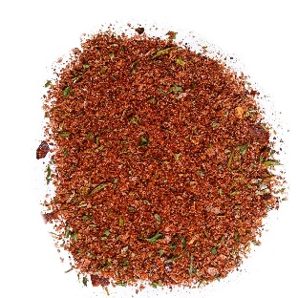
- World events
- Climat Change
- Seasoning (the 4 seasons)

Survival Mechanics:
- Dealing Damage
- Health
- Eating
- Drinking
- Fleeing
- Settling
- Grouping (finding a pack)

Player Dynamics:
- Riding creatures
- Burning food

- INCLUDES SURVIVAL DYNAMICS*

Creature Dynamics:
- Mating

- INCLUDES SURVIVAL DYNAMICS*

Survival Dynamics:
- Dying (starvation, drowning, fatigue, pain, frostbite, sunburn, dehydration)
- Preventing death
- Defending Shelter
- Killing
- Consuming
- Getting Drunk

Special ideas:
- Out of body experience

Misc Ideas
- 3d print character model (for motivation/pride)

